First Trial of OPALs: Second Workshop on 9 September 2022
NRI Foundation, 21 October

Description of the workshop
On 9/9/22 in the Quinn Developments offices in Knowsley, the facilitators (Kingston and Gordon Crick) started the session with a short presentation (see Appendix). Managers were reminded about the aim of the OPALs trial, the approach at the first workshop, and the agenda for this—the second workshop.
Before making the presentation, the facilitators set up a generous area (1.2m by 3.2m) of wall space on which to make notes of points arising from the discussion of the two cases. This consisted of two overlapping rows of ‘magic chart’—a product that sticks electrostatically to walls, holds enough static charge to allow papers to be fixed, and on which notes can be written using marker pens. A digital system would be ideal for record keeping and a ‘professional look’, but the usability and reliability of this set up are good.
The participants were each given two A4 pages (see Figure 1, and the Appendix) that summarised the results of the first workshop, one for the 275kV strike and the other for the trench collapse. These pages preserved the relative vertical positions of precautions according to the Haddon hierarchy. Critical incidents and opinions were summarised on each page to the right of the precautions. The aim was to summarise the findings of the first workshop (OPAL polishing) in a format that managers at the second workshop (OPAL setting) would find convenient.
Figure 1. Sheet summarising results of the first workshop
The facilitators allowed the discussion to move freely, with managers picking-up points that seemed salient to them. As issues emerged, the facilitators noted them down on the chart. The 275kV strike was discussed first case. Before moving to the trench collapse case, the (275kV) chart was photographed and a new chart put up. The results are given below.

Results of the workshop
The photograph of each chart and a summary of the findings is given here for each of the two cases.
275kV strike case
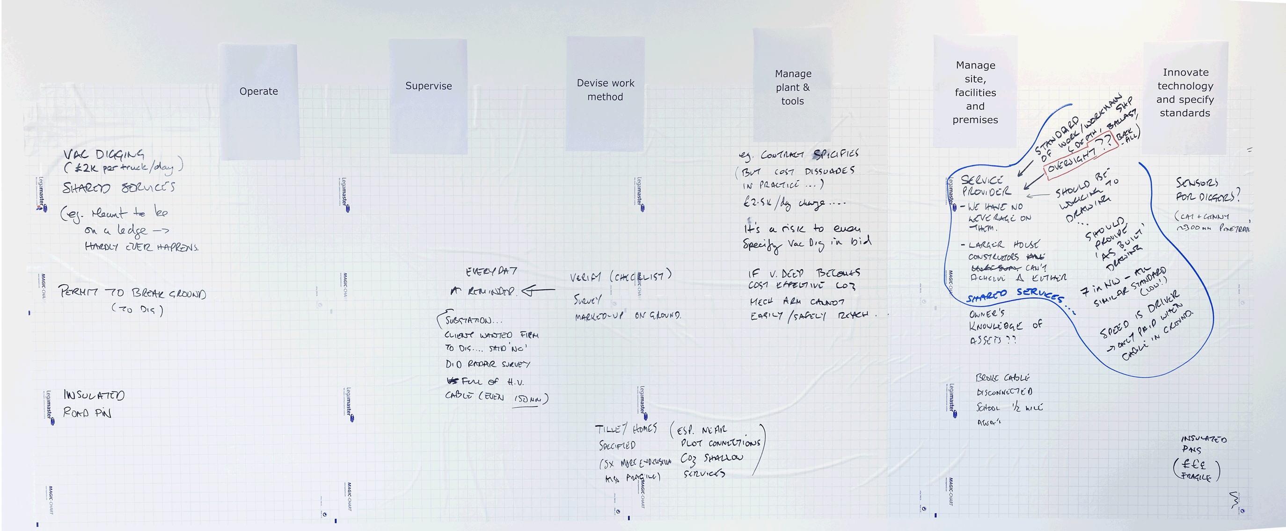
Figure 2. Chart summarising discussion of the 275kV strike case
Two precautions added: insulated road pins and ground penetrating radar (GPR)
- Insulated road pins especially for exactions near plot connections. Example. Cautionary note: Insulated road pins are fragile and cost 3 to 5 times more than steel road pins). Some clients (e.g. Tilia Homes) specify them.
- Ground Penetrating Radar (to augment survey using CAT and Genny electromagnetic detectors). Example.

Implementation issues
- Implementing vacuum digging
  - Even if contract specifies vacuum digging, the cost (~£2.5K/day) will discourage implementation in the method statement;
  - To improve chances of a bid succeeding on grounds of cost, contractors may not specify vacuum digging;
  - However, if excavation is deep, vacuum digging becomes cost-effective as a mechanical arm cannot easily or safely reach (without caving in edge).
- Using a ‘permit to break ground’ (this will specify various physical actual precautions, the permit itself is a means of implementing them).
  - The method statement should specify the permit.
  - The requirements of permit should be verified every day (i.e. physical precautions in place, and methods agreed).
  - A story was shared about a client who wanted the contractor to dig without a permit. This was resisted and a radar survey done. The area to be dug was found to be ‘full’ of high voltage cables, some as shallow as 150mm below the soil surface)
- Implementing Shared Services (e.g. Services are meant to run along on a ledge in the trench, but hardly ever happens in practice)
  - Shared services are implemented by service provider contractors. Their workmanship, in this respect and others, is often poor (e.g. depth of trench, ballast quality) and unreliable.
  - “They should be working to drawing (but don’t)”.
  - There are seven service contractor firms in the northwest, all share similar low standards
  - “We have no leverage on them”.
  - “Even larger house constructors can’t achieve change (i.e. improvement) in services contractors’ standards of work.”
  - “No oversight of service contractors”. “No check before backfill”.
  - “Speed is the commercial driver; they are only paid when the cable is in the ground”.
  - Story of breaking a cable that disconnected a school located half-a-mile away.
  - See point made in trench collapse case concerning possibility to improve implementation of precautions via NHQB.

Trench collapse case
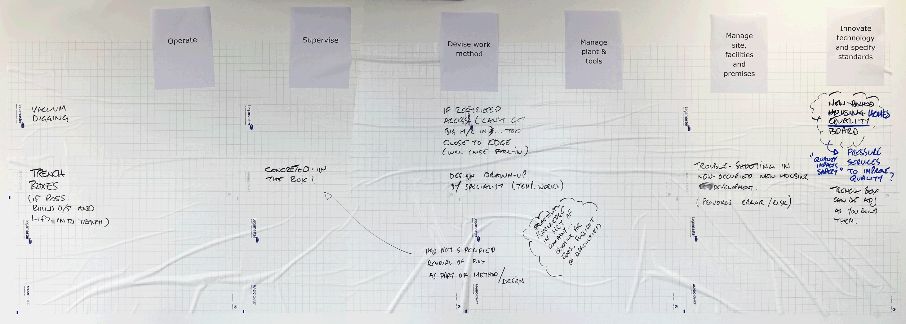
Figure 3. Chart summarising discussion of the trench collapse case
Implementation issues
- Implementing vacuum digging
  - Vacuum digging is most likely to be implemented in situations where access is too restricted to allow a big machine in or where trench is too deep to allow a mechanical arm close to the edge (i.e. a risk of edge collapse)
- Implementing trench boxes
  - If possible, build a trench box outside then lift into trench.
  - It would be ideal to have a trench box design which allows them to be adjusted as they are built. (Technical innovation).
  - Story of a trench box that was concreted-in and required huge effort to remove. The design drawn-up by a temporary works specialist who did not specify removal of box in the design/method.
  - Method statements (and foresight of difficulties) rely on the practical knowledge possessed by managers of the companies quoting for jobs.
  - General point: Once they are occupied, trouble-shooting in new housing developments provokes error and increases risks.
  - General point: Quality of work impacts on safety. The ‘New Homes Quality Board’ may be an avenue to pressure services companies to improve their quality of work.

Next step for this trial with Quinn
One principle of OPALS is communication between operators and managers. The review of the operators’ workshop by the managers’ workshop is one part, but the loop needs to be closed. It is important that the loop is closed in a way that convinces operators that their insights have been heard and valued by their managers. This will encourage workers both to treat the content of the exercise as valid and to want to participate in the future.

How should the loop be closed in a way that convinces workers about the credibility of the exercise? One contribution, insufficient in itself but useful in part, are the summaries of the workshop (e.g. Figure 1, above). The managers felt that these were self-explanatory and would show that managers had added some value to the workers’ efforts. The managers suggested that the minimum would be to post these sheets on notice boards seen by the operatives.

In addition, the facilitators suggested, something a little more participatory would be needed in the interests of engagement. For example, a toolbox talk that explained the sheets and gave some insight into the managers session. This might be enough for some workers, but some change might be even more convincing. It is suggested that Quinn management reflect on the opportunities implied in the findings of the second workshop. One possibility is to approach the recently set up New Homes Quality Board with the concerns raised in connection with the poor implementation of shared services.

Whichever choices Quinn makes, NRI would be grateful if they would let NRI know what steps they take to close the loop.

Points about OPALS method
The facilitators noted that the operatives’ workshop may need an extra stage. They also recognised that ‘upstream—downstream’ might be a good way to refer to the levels of implementation that are central to the second, managers’ workshop.
The managers workshop—to ‘set’ the OPALs that were ‘polished’ in the operators’ workshop—added some of the hoped for insights into implementing precautions. It endorsed the precautions noted by the workers and the managers added one or two of their own. However, the test of salience—which precautions are worth discussing—was left implicit.
In the two cases used, most of the discussion focussed on the shortcomings of third parties rather than opportunities to improve practices at Quinn. This may be entirely justified because of the cases chosen and the high degree of technical knowledge possessed by Quinn’s managers. However, for other cases and for firms staffed by managers who have less practical knowledge, the OPALs method needs to better reflect workers’ ideas of salience.
One way of directing salience would be to add a stage to the ‘polishing’ process. Sharing stories—critical incidents—remains the strongest data: managers will respect first hand experience, even if they want to argue about what it means. However, even when it elicits no stories, workers might nonetheless feel that a precaution cannot be taken for granted. In such cases, the OPALs method should pass on these concerns to managers. One way of doing this is to add a stage that rates (e.g. 1-5) the reliability of every precaution. This might also have the effect of prompting stories for low-rated precautions. Against this idea is the extent to which managers will feel challenged. Ideally, a manager’s response will be to reflect and devise improvements. However, challenge might bring forth defensiveness in managers, so it’s something we need to think-through and maybe experiment with.

Conclusions
An OPALs exercise consists of two workshops. The first workshop is an OPALs polishing workshop for operatives that identifies and shares information about precautions. The second workshop, the OPALs setting workshop, reviews the material produced by the operatives, reflecting on the how the precautions are implemented in practice.
The scheme (six upstream—downstream levels of implementation) provided a workable way for managers to discuss the precautions, stories and opinions of their worksite colleagues.
An extra stage may be needed for the operative workshop to better indicate how reliable workers’ believe precautions to be.
How managers report back to workers is a matter for further development. Closing the loop for workers is believed to be crucial to the credibility of an OPALs exercise. NRI hopes to collect information from Quinn Developments about this.
NRI is extremely grateful to Quinn for their support.

Slide 1 (Workshop 2)

Slide 2 (Workshop 2)

Slide 3 (Workshop 2)

Slide 4 (Workshop 2)

Slide 5 (Workshop 2)

Slide 6 (summary of workshop 1 findings)
Slide 7 (summary of workshop 1 findings)

Slide 8 (summary of workshop 1 findings)

Slide 9 (Workshop 2)

Slide 10 (Workshop 2)

